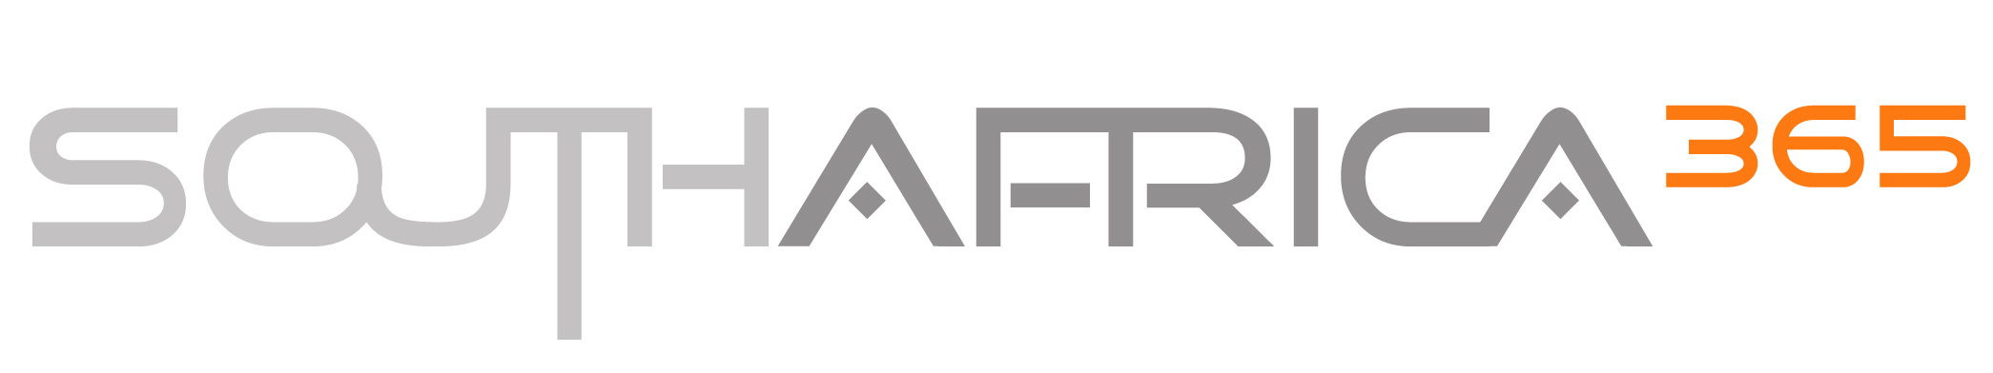

South Africa 365 Industry Affiliations

Southern Africa Tourism Services Association (SATSA)

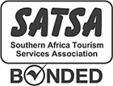
SATSA is the member driven association representing the private sector of the incoming tourism industry in Southern Africa. SATSA is a non-profit association, dedicated to providing and maintaining the highest possible standards in the tourism industry within South Africa.
Should the member (South Africa 365) become financially insolvent prior to rendering the contracted service, the bond, which has an indemnity limit of R1.5 million, guarantees that deposits will be refunded, or the service replaced, to a maximum level of R300 000 per event or R75 000 per claim against the insolvent member.
This is an insurance bond underwritten by Lombard Insurance and certain underwriting syndicates at Lloyd's of London and is administered by SATSA, a section 21 company incorporated not for gain.
South Africa 365 Travel cc
Chapter Member - Tour Broker
SATSA member no. 1649

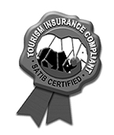
Safari & Tourism Insurance Brokers (SATIB)

This seal of approval certifies that the South Africa 365 holds certification of insurance issued by Safari & Tourism Insurance Brokers (SATIB) and certain Lloyd's of London Underwriters, which comply with the European Community Directive (90/314/EEC) and carry one or more of the following minimum cover levels:

- South Africa 365 policy number 0600928-PI07/2007/0251
- Professional Indemnity cover to a maximum value of R2 million
- Endorsed by the Southern Africa Tourism Services Association (SATSA)
- Subject to Terms & Conditions as set out in the relevant policy documents.

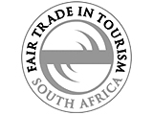
Fair Trade in Tourism SA (FTTSA)

A non-profit organisation initiative that certifies tourism businesses for operating according to the principles of ‘fair trade’. FTTSA awards a special Trademark or label to qualifying businesses as a way of signifying their commitment to these principles (fair share, democracy, respect, reliability, transparency, sustainability) and related criteria, including fair wages and working conditions, fair purchasing, fair operations, equitable distribution of benefits and respect for human rights, culture and environment.

By electing to stay at or use the services of a FTTSA certified establishment, tourists can be assured that their travel benefits local communities and economies, and that the business is operated ethically and in a socially and environmentally responsible manner.

TourMed South Africa

Travel insurance is offered through TourMed South Africa (underwritten by AIG), a specialist insurance provider for travel within Southern Africa. We advise all clients to take adequate travel insurance.
Standard travel policies includes medical and cancellation insurance, and have been specifically designed to cover visitors to South Africa, Namibia, Zambia, Botswana, Zimbabwe, Tanzania, Kenya and Mozambique. Please request schedule of benefits for exact details.

